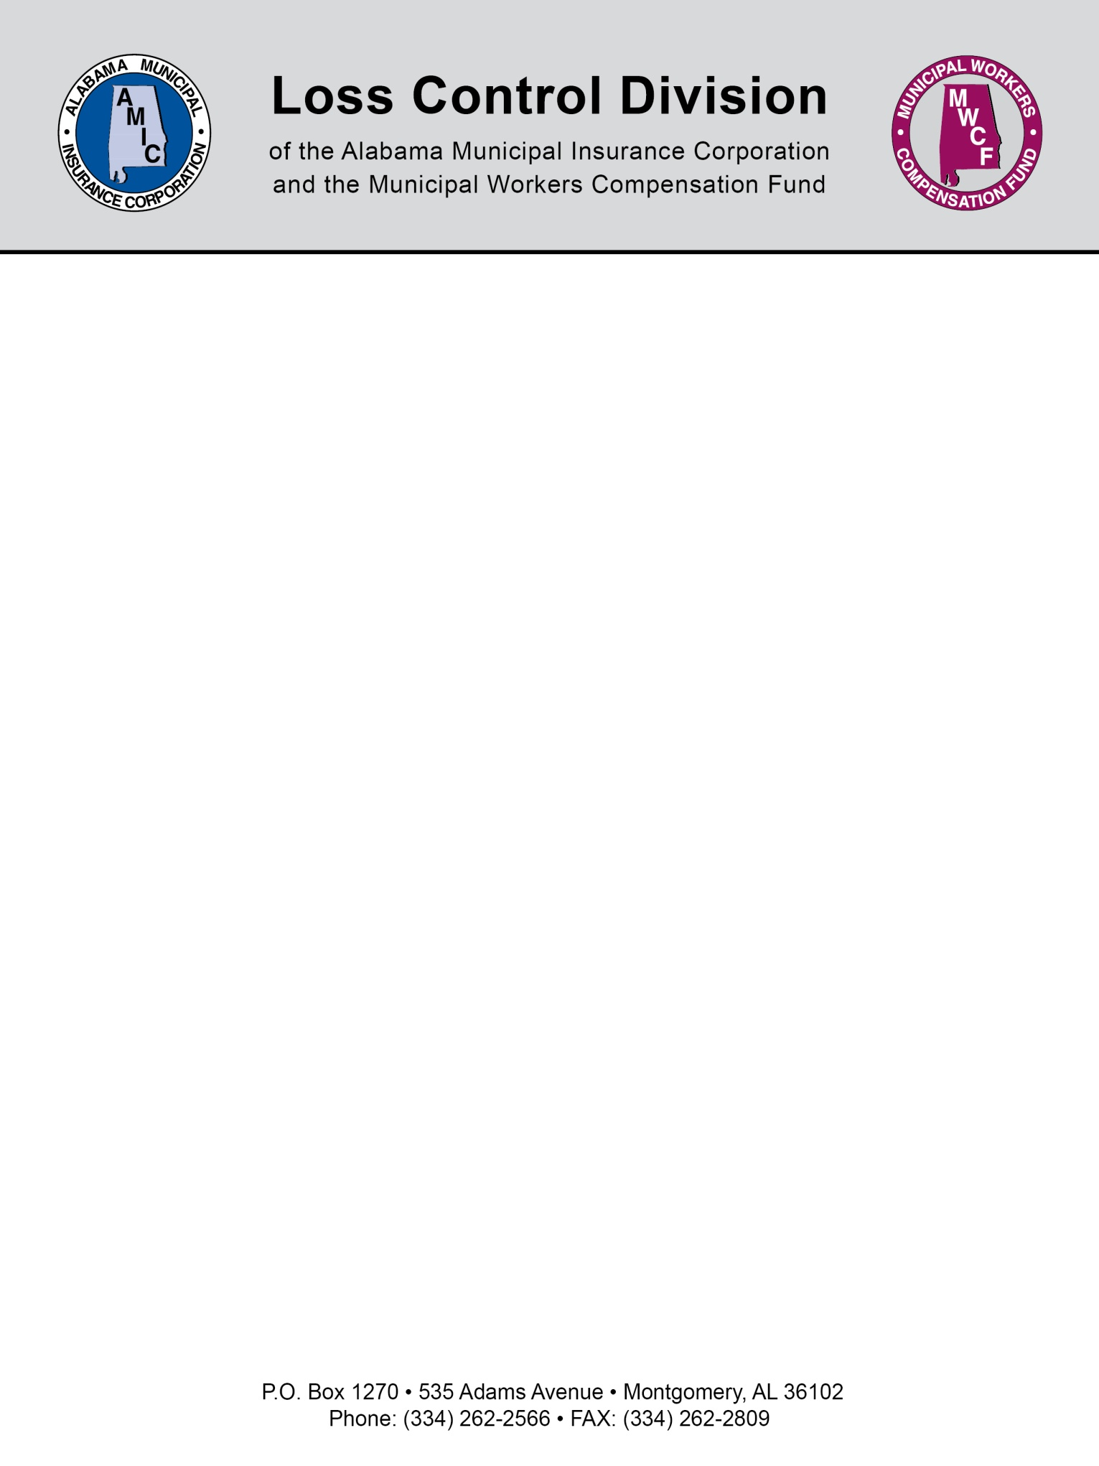

Equestrian Event Signage Statute

Section 6-5-337

Immunity of those involved in equine activities.
(a) The Legislature recognizes that persons who participate in equine activities may incur injuries as a result of the risks involved in those activities. The Legislature also finds that the state and its citizens derive numerous economic and personal benefits from equine activities. The Legislature finds, determines, and declares that for the immediate preservation of the public peace, health, and safety, and to encourage equine activities, this legislation is to limit the civil liability of those involved in equine activities.
(b) As used in this section, the following words shall mean the following unless the context clearly indicates otherwise:
(1) ENGAGES IN AN EQUINE ACTIVITY. Riding, training, providing, or assisting in providing medical treatment of, driving, or being a passenger upon an equine, whether mounted or unmounted, or any person assisting a participant or show management in equine activities. The term does not include being a spectator at an equine activity, except in cases where the spectator places himself or herself in an unauthorized area and in immediate proximity to the equine activity.
(2) EQUINE. A horse, pony, mule, donkey, ass, or hinny.
(3) EQUINE ACTIVITY. Any of the following:
a. Equine shows, fairs, competitions, performances, or parades that involve any or all breeds of equines and any of the equine disciplines, including, but not limited to: dressage, hunter and jumper horse shows, grand prix jumping, three-day events, combined training, rodeos, driving, pulling, cutting, polo, steeplechasing, English and western performance riding, endurance trail riding and western games, and hunting.
b. Equine training or teaching activities, or both.
c. Boarding equines.
d. Riding, inspecting, or evaluating an equine belonging to another, whether or not the owner has received some monetary consideration or other thing of value for the use of the equine or is permitting a prospective purchaser of the equine to ride, inspect, or evaluate the equine.
e. Rides, trips, hunts, or other equine activities of any type, however informal or impromptu, that are sponsored by an equine-activity sponsor.
f. Placing or replacing horseshoes on an equine.
g. Examining or administering medical treatment to an equine by a veterinarian.
(4) EQUINE ACTIVITY SPONSOR. An individual, group, club, partnership, or corporation, whether or not the sponsor is operating for profit or nonprofit, which sponsors, organizes, or provides the facilities for an equine activity, including, but not limited to: pony clubs, 4-H clubs, hunt clubs, riding clubs, school and college sponsored classes, programs, and activities, therapeutic riding programs, and operators, instructors, and promoters of equine facilities, including, but not limited to, stables, clubhouses, ponyride strings, fairs, and arenas at which the activity is held.
(5) EQUINE PROFESSIONAL. A person engaged for compensation in:
a. Instructing a participant or renting to a participant an equine for the purpose of riding, driving, or being a passenger upon the equine.
b. Renting equipment or tack to a participant.
c. Examining or administering medical treatment to an equine as a veterinarian.
(6) INHERENT RISKS OF EQUINE ACTIVITIES. Those dangers or conditions which are an integral part of equine activities, including, but not limited to:
a. The propensity of an equine to behave in ways that may result in injury, harm, or death to persons on or around them.
b. The unpredictability of the reaction of an equine to sounds, sudden movement, and unfamiliar objects, persons, or other animals.
c. Certain hazards such as surface and subsurface conditions.
d. Collisions with other equines or objects.
e. The potential of a participant to act in a negligent manner that may contribute to injury to the participant or others, such as failing to maintain control over the animal or not acting within his or her ability.
(7) PARTICIPANT. Any person, whether amateur or professional, who engages in an equine activity, whether or not a fee is paid to participate in the equine activity.
(c)(1) Except as provided in subdivisions (c)(2) and (c)(3), an equine activity sponsor, an equine professional, or any other person, which shall include a corporation or partnership, shall not be liable for an injury to or the death of a participant resulting from the inherent risks of equine activities and, except as provided in subdivisions (c)(2) and (c)(3), no participant or representative of a participant shall make any claim against, maintain an action against, or recover from an equine-activity sponsor, an equine professional, or any other person for injury, loss, damage, or death of the participant resulting from any of the inherent risks of equine activities.
(2) Nothing in subdivision (c)(1) shall prevent or limit the liability of an equine-activity sponsor, an equine professional, or any other person if the equine-activity sponsor, equine professional, or person:
a. Provided the equipment or tack, and knew or should have known that the equipment or tack was faulty, and the equipment or tack was faulty to the extent that it did cause the injury.
b. Provided the equine and failed to make reasonable and prudent efforts to determine the ability of the participant to engage safely in the equine activity and to safely manage the particular equine based on the participant's representations of his or her ability.
c. Owns, leases, rents, or otherwise is in lawful possession and control of the land or facilities upon which the participant sustained injuries because of a dangerous latent condition which was known or should have been known to the equine-activity sponsor, equine professional, or person and for which warning signs have not been conspicuously posted.
d. Commits an act or omission that constitutes willful or wanton disregard for the safety of the participant, and that act or omission caused the injury.
e. Intentionally injures the participant.
(3) Nothing in subdivision (c)(1), shall prevent or limit the liability of an equine activity sponsor or an equine professional under liability provisions as set forth in the products liability laws.
(d)(1) Every equine professional and every equine-activity sponsor shall post and maintain signs which contain the warning notice specified in subdivision (d)(2). Signs shall be placed in a clearly visible location on or near stables, corrals, or areas where the equine professional or the equine-activity sponsor conducts equine activities. The warning notice specified in subdivision (d)(2) shall appear on the sign in black letters, with each letter to be a minimum of one inch in height. Every written contract entered into by an equine professional or by an equine-activity sponsor for the providing of professional services, instruction, or the rental of equipment or tack or an equine to a participant, whether or not the contract involves equine activities on or off the location or site of the equine professional's or the equine-activity sponsor's business, shall contain in clearly readable print the warning notice specified in subdivision (d)(2).
(2) The signs and contracts described in subdivision (d)(1) shall contain the following warning notice:
“WARNING:
Under Alabama law, an equine activity sponsor or equine professional is not liable for an injury to or the death of a participant in equine activities resulting from the inherent risks of equine activities, pursuant to the Equine Activities Liability Protection Act.”
(3) Failure to comply with the requirements concerning warning signs and notices provided in this section shall prevent an equine-activity sponsor or equine professional from invoking the privileges of immunity provided by this section.

(Acts 1993, No. 93-601, p. 976, §§1-4; Act 2004-627, p. 1421, §1.)

NOTE: This document is not intended to be legal advice. It does not identify all the issues surrounding the particular topic. Public agencies are encouraged to review their procedures with an expert or an attorney who is knowledgeable about the topic. Reliance on this information is at the sole risk of the user.

Revised 9/2013

